Step 1:

--Ask client to zip up the entire CDP_Service folder and send it to CrunchTime. This will eliminate any back and forth of not receiving the appropriate log files that will need to be examined.

Step 2:

--Have the client go into their Services and have them right click on CDP Service.

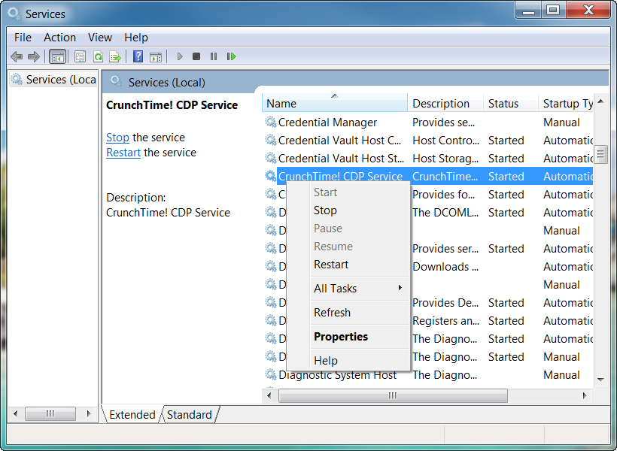--Select Properties

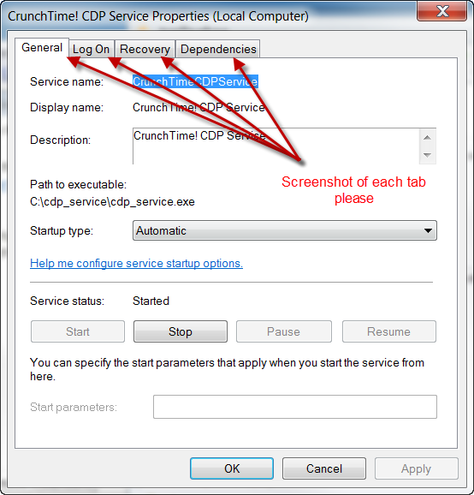--Screenshot each tab's information.

--Send to CrunchTime

--Then forward all the information sent to Tim Callaghan to troubleshoot.

Step 3: **Only if requested by Tim**

1) Open Windows Event Viewer

2) Select “Windows Logs” -> “System”

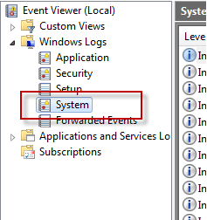

3) Click “Filter Current Log...”

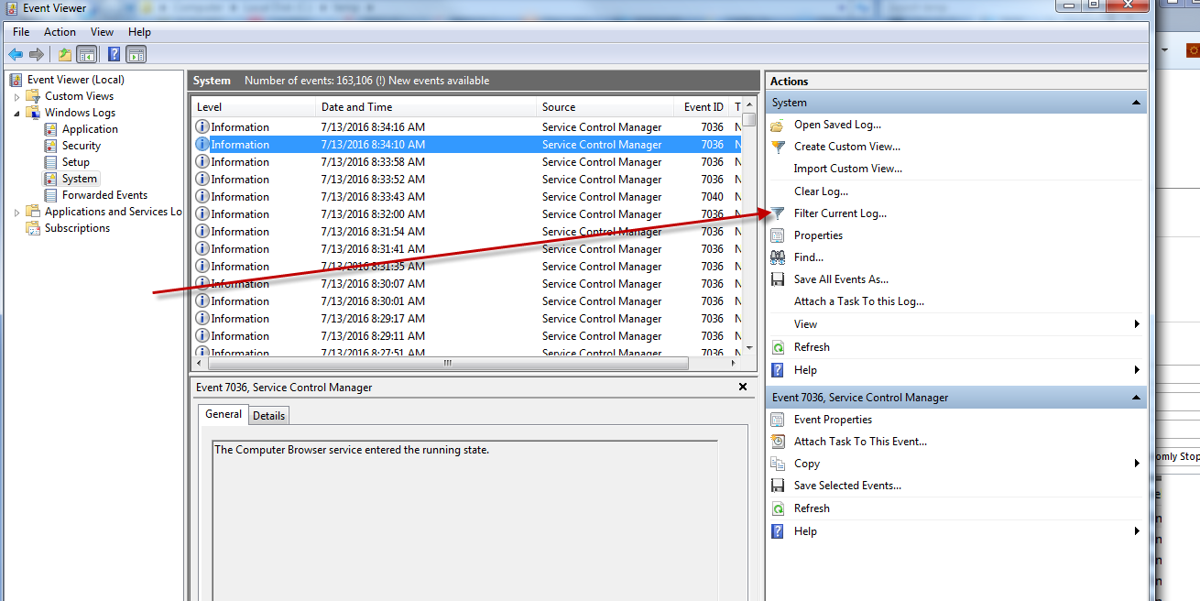

4) Enter “6005, 6006” in the highlighted field and click OK.

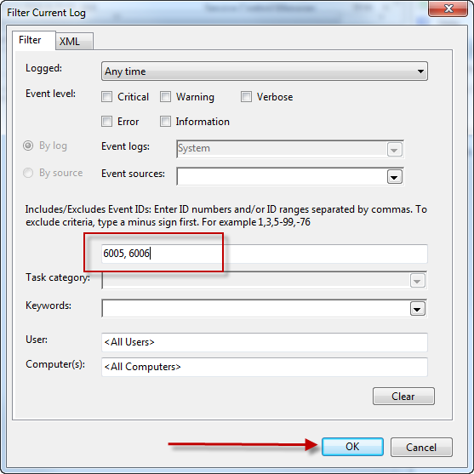

5) Click “Date and Time” so the newest data is on the bottom.

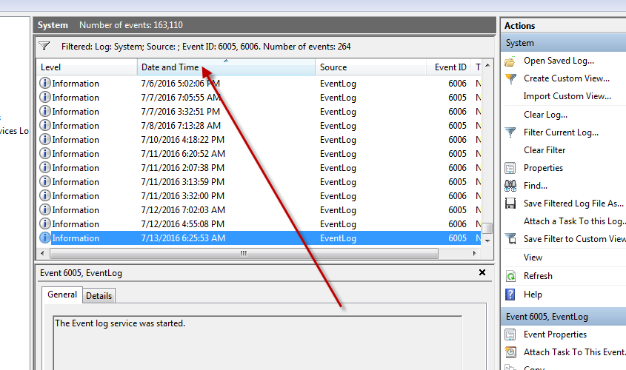

6) Highlight the bottom (newest) row and select/highlight up to the first row in the previous month.

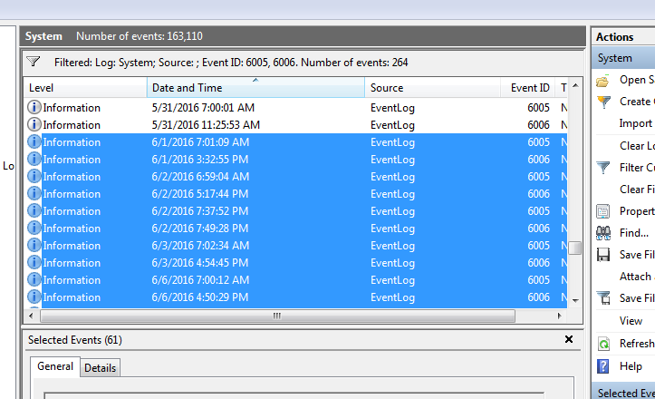

7) Right click the highlighted rows, select “Save Selected Events...”

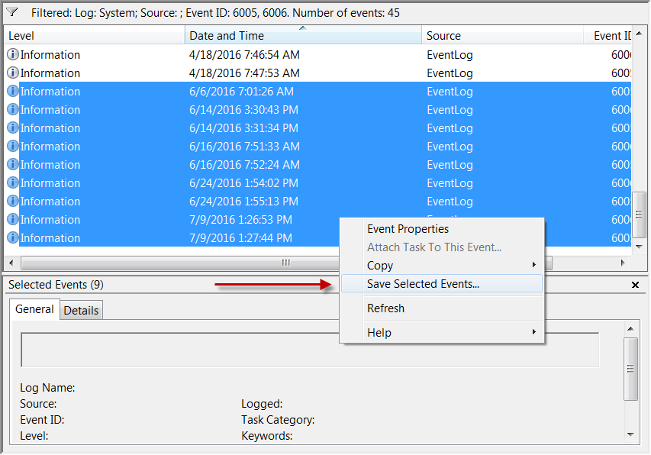

8) Name it anything, be sure to change “Save as type” to be “Text (Tab delimited) (*.txt)”

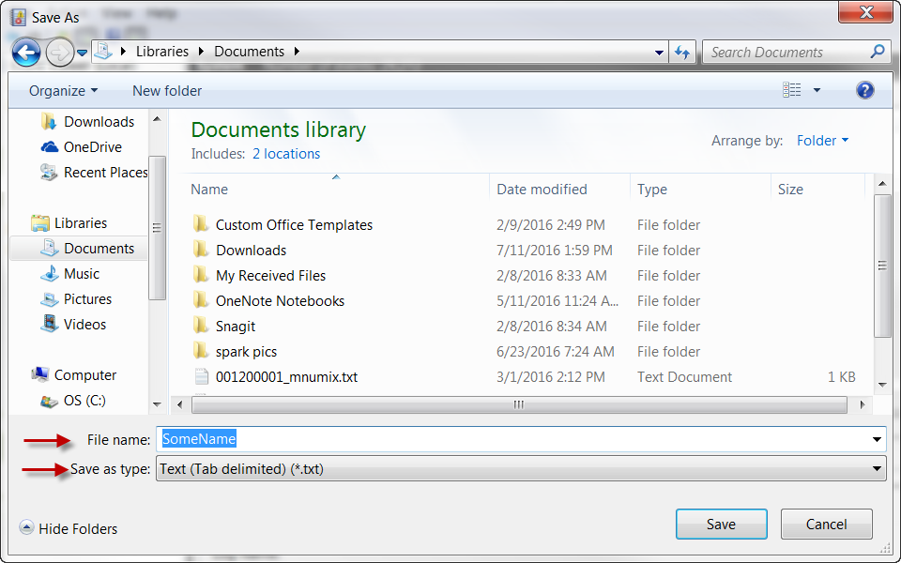

9) Have client send CrunchTime the file.

Step 4:

Send events file to Tim Callaghan to view.